**4 – lesson four (2365)**

We did two modifications to the circuit in lesson four. The first modification was to add another light switch. This is mark by the annotation in the below picture Electrical Area 1 (EA 1). The second modification was to add another light fitting. It was added adjacent to the light fixture already situated on the board.

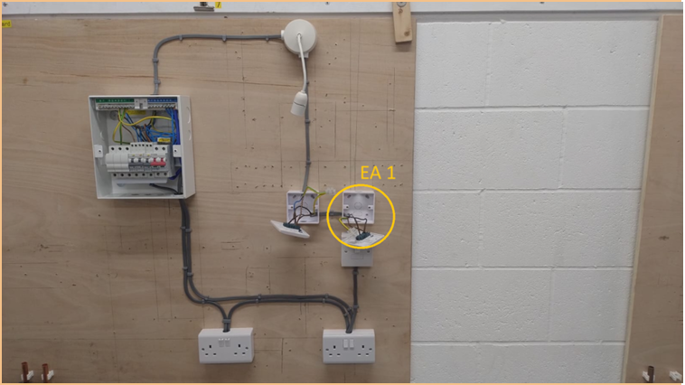

Wide view Close-up of light switch Close up of light switch 2 Close up of light switch 3

Sleeving is used to identify whatever the wire is used for. Grey is used for live however we could also use black.

Switches are not CUD – Current Using Device. This is why in the test we do not use it as the furthest device away. Lights, on the other hand, are; specifically the rise ceiling plate.

When we test the live and earth wires and it passes. This means that polarity can be ticked on the test sheet.

We connect the live wire and the yellow and green wire to the connector block. We take the latter two wires from the breaker in the fuse box that corresponds to the circuit we want to test. In this case it was circuit/breaker three. The third from the right.

